Midterm Project Report

Nikoletta Dimitriadi (267137)
ITC 4214 Internet Programming
Dr. Leonardos Mageiros
March 04, 2026

Contents
Github link 3
Description of Task Allocation System 3
Coding decisions 3
Tasks page 3
Latest activity 4
Personal page 4
Chrome Lighthouse 5
index.html 6
discover.html 7
tasks.html 8
contact_us.html 8
about_us.html 8
Reflections 8

Github link
Please run my code using the Live Server extension on Visual Studio Code.
https://github.com/ndimitriadi/Dimitriadi_Midterm_Project

Description of Task Allocation System
The task allocation system implemented in Athenian Nectar is a personalized itinerary management system. Users are given the opportunity to interact dynamically with the website by saving, organizing and tracking their Athens destinations. It is all based on a table where they can create, edit and delete locations. It operates on the client side by utilizing the browser’s localStorage API, which stores data locally even if the tab is refreshed/closed. Users can filter their favorite places by Status (Pending/Visited) or Priority (Optional, Maybe, Must Visit), as well as sort them by Date or Place name.

Coding decisions

Tasks page
In the tasks page, the focal point is the interactive Javascript table with user input. I started off by designing the structure of the table and then using Javascript I made it functional. The table displays the user’s favorite destinations name, description, date, status and priority.
All this information is stored in a single array called “tasks”, which is modified consistently by the other elements of the code according to user preference. In order for this to work, one of the key components of the code is the “render_table” function that is responsible for clearing everything and rebuilding the table according to the updated array. This way we don’t need to modify individual DOM elements after each action, we just re-render the table.
The user is also able to edit and delete tasks, even when the table is sorted and/or filtered. The problem was that the new row index didn’t match the original array index. A solution was to give to the ‘original’ tasks an “original_index” before filtering and/or sorting, so that the correct task was modified in localStorage.

Latest activity
The latest activity section located on the home page (index.html) displays the three latest saved places of the user along with the priority, date and status. The script gets the “task” array from localStorage and using array methods (slice and reverse) it acquires the three newest entries of the user and displays them. In order for this to work dynamically, individual cards for every “task” were created inside the script. New elements were created and then styled in “tasks.css” (“.recent-task-card”). Lastly, if the tasks array were to be empty, a friendly message appears to the user encouraging them to take action.

Personal page
My personal page is “discover.html”, a page that provides the user real-time weather information through an API and blog posts about food/drink spots in Athens that they can add to their “tasks” table. Moreover, there is a search bar that filters the blogs according to user input.
For the weather information I used an external weather API (Open-Meteo) in an asynchronous function (“athens_weather”). It fetches real-time data, using coordinates, that are stored in two values, “temp” and “code”. Using the value of “code” the bootstrap icons are updated according to the weather conditions and along with the description (Clear Sky, Rainy) and the temperature it gets displayed. Since we are using an external API I implemented a try and catch block that will handle failure by displaying a message to the user.
Additionally, I wanted to make the page more interactive with the user, so I added a “Save to Favorites” button on every blog post. When it gets clicked the script checks if the place already exists in the “tasks” array in the localStorage. If not, it adds it, with a default description and status and the bootstrap icon changed to visualize that the action is done. Moreover, the user can also unsave the place by pressing the button again or going to “tasks.html” and removing it from the table.
Lastly, I added a search filter where user input is captured and compared to the title, category and description of each “.blog-card”. To ensure that the filtering works correctly, the input is first converted to all lowercase before it gets compared to the other values. If there are matching results, they are displayed while the other cards get hidden. If there are not, a message appears to the user.

Chrome Lighthouse
In order to evaluate the site’s accessibility, SEO and performance, Chrome Lighthouse was used on every page of the website.
The initial results I got helped me improve accessibility significantly. I realized that everything was taken into consideration, like mobile padding space, color contrast and wrapping my page contents in <main>. My score is not perfect since the main color I used for my website is not the best according to Chrome Lighthouse because there isn’t sufficient contrast ration. Other points were deducted from the accessibility score due to touch targets not having sufficient size or spacing. I realized all this too late, after I had finished my project and I decided I wouldn’t change them.
Initially I was surprised that performance in two of my pages (index.html and discover.html) wasn’t ideal, but after I saw the metrics, I understood why. It was mainly the Largest Contentful Paint (LPC) in both cases I have used large images/data in size that the webpage needs time to load.

index.html
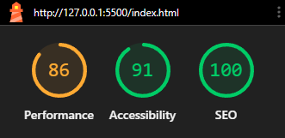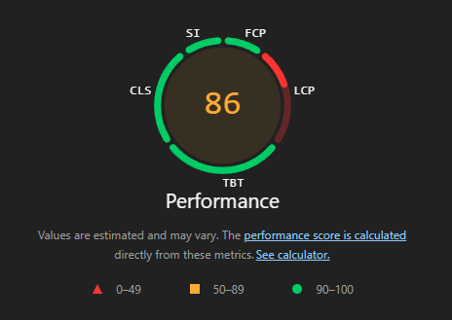
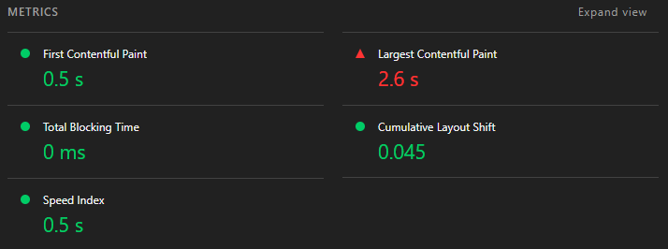

discover.html
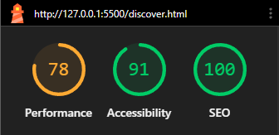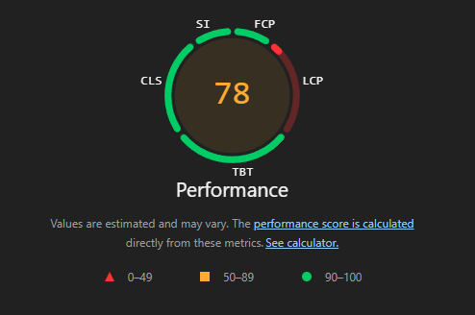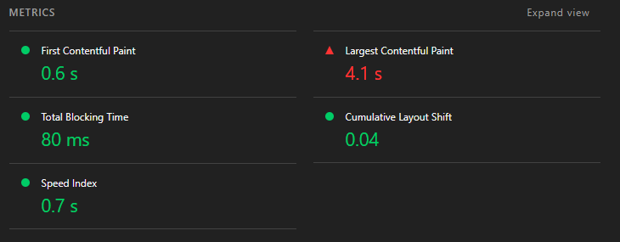

tasks.html
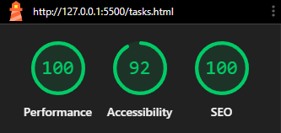

contact_us.html
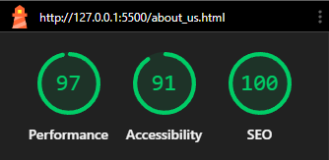

about_us.html
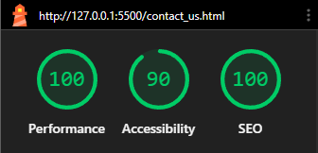

Reflections
This project overall was a great and rewarding experience with a lot of ups and downs. Using Git was very reassuring and it made me not afraid to change my code. I was very encouraged to seek my own knowledge and get ideas from others, which made this an amazing experience. Of course there were some challenges along the way.
Firstly, ensuring that my website was accessible wasn’t as easy as imagined. I didn’t expect to have to take into consideration so many elements and having a project that continuously grew in size meant that I had to dedicate a lot of time. Chrome Lighthouse helped me realize what I had to improve and how coding must accommodate everybody.
Secondly, task management was very interesting and complex. Having to figure out how to utilize localStorage and realizing that sorting and filtering required an original index in order to function properly. Additionally, wanting to implement the idea of adding favorites from another page was scary at first but ended up being simpler than what I imagined.
Also, the external API was a challenge. I had to try multiple ones until I found the one that worked for me. Also figuring out that I had to request the information that I want through the link and then process the information received correctly so it can be readable.
Moreover, I never realized how complex the logic behind carousels was. Building the testimonials carousel was very interesting, wanting to make it loop infinitely was difficult. After research I found the solution with the cloned cards, and it took some time to get it right. Additionally, I had a hard time with the CSS styling, I am still not fully satisfied with the way it looks, but it was very complicated to get it to fit in with the aesthetic of the website.
Lastly, implementing dark mode was also challenging at first. Having to map elements to variables and giving them specific colors didn’t always work due to priorities. In many cases I found out that I needed to be extremely specific about which element I was referring to in order to see a change. Also, I didn’t expect to have to use localStorage here as well in order to save the user preference and be consistent.

